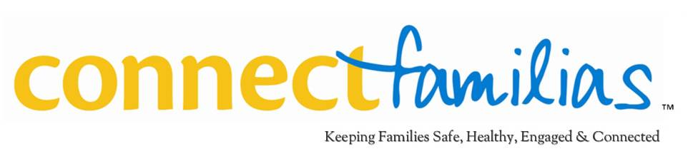

For Immediate Release Contact: Betty Alonso, ConnectFamilias
Email: Betty@hfsf.org, Phone: 305.803.3405

Little Havana Residents Will Benefit From Health Foundation’s Healthy Community Partnerships Initiative Hosted by ConnectFamilias.

With health affected by most factors outside clinical care, the Foundation is allocating up to
$7.5 million over six-years to bridge multiple sectors in each community to advance health

Miami, December 13, 2013 –With research indicating that how we live, where we live and other social and economic forces can have dramatic effects on health, new kinds of partnerships will play an increasingly important role in improving community health. Health Foundation of South Florida is targeting the improvement of community health indicators by allocating up to $7.5 million to support two Healthy Community Partnerships over a multi-year period.

After an extensive evaluation process, Health Foundation of South Florida has announced that ConnectFamilias would serve as the host agency in Little Havana for its Healthy Community Partnerships initiative. This initiative is part of the Foundation’s strategic and systemic effort to reduce poor health outcomes by engaging community residents to improve selected public health indicators. A diverse coalition of residents, organizations and other groups representing eight communities in Miami-Dade County made a collaborative effort and applied for this opportunity to improve health for their residents. The City of Miami Gardens was selected as the second site.

According to Health Foundation of South Florida Board Chairman Richard Laviña, “We all have a stake in improving health, but no one can do it alone. “ He added, “We need collaboration to create a process for holistic and systemic change. This includes entities in business, education, government, community development, philanthropy and other sectors. We all have something important to bring to this work.”

The community of Little Havana receives up to $625,000 per year for a six-year period for grant making and program implementation. “We each have an important part to play in transforming our neighborhood and making it a healthier place for everyone,” said ConnectFamilias President/CEO Betty Alonso. She added, “We encourage everyone to join us by taking steps as simple as increasing physical activity or by getting involved in Healthy Community Partnerships.”

About Health Foundation of South Florida: Health Foundation of South Florida, a nonprofit grant making organization, is dedicated to improving health in Broward, Miami-Dade and Monroe Counties. By advancing health solutions, the Foundation makes a measurable and sustainable impact in ensuring access to affordable, quality health services for all residents. Since 1993, the Foundation awarded more than $104 million in grants and program support. For more information, please call 305.374.7200 or visit www.hfsf.org.

About the Little Havana Community: Little Havana has the highest concentration of Hispanics (98 percent) in Miami-Dade County. The neighborhood maintains a strong cultural heritage and Hispanic identity, with a unique mixed-use zoning corridor that includes small ethnic businesses, such as cigar factories/stores and an open air domino park. It serves as the host site for the Calle Ocho festival, as well as a monthly arts and culture festival. Little Havana contains some of the oldest and most historic buildings in Miami, including classic bungalows and the historic Tower Theater. The neighborhood contains a number of parks, local schools, and diverse community champions, many of whom are affiliated with the Little Havana Healthy Community Partnership.
ConnectFamilias, the lead agency for the Little Havana Health Community Partnership, has worked since 2007 to build a comprehensive neighborhood-based and family focused collaborative that supports the health, safety, and overall well-being of children in Little Havana. The partnership’s mission is to maintain an efficient, consistent, and holistic network of coordinated services that increases the safety and well-being of children, youth, and their families. ConnectFamilias works from the premise that children do better when their families are strong and are connected to a community that helps them succeed as productive citizens.
The Little Havana Healthy Community Partnership is being funded by the Health Foundation of South Florida. Media information: Betty Alonso, betty@ConnectFamilias.org; Office: 305.854.2973 ; Mobile: 305.803.3405

###

